

Aya Elneanaei Fouda 202002609

Ahmed Emad Osman 211001752

Ahmed Shrife Zahran 202000905

Ahmed Hamdy Harb 211001737

Abdelrahman Ahmed Reyad 202001902

Yousef Amro Saad 211001250

## Dr.Marwa Aref Sorour

Face Recognition

Linear Algebra

Table of Contents

Abstract…………………………………………………………………………...

Introduction……………………………………………………………………….

1. Background………………………………………………………

## Literature Review………………………………………………………………….

1. Stages of Face Recognition System…………………………….
2. Face Detection Techniques……………………………………...
3. Life Applications of Face Recognition System………………….
4. Successful Use Cases of Face Recognition System………………
5. What is the relation about linear algebra and face Recognition……
6. The development stage of face recognition and related technologies...

Methodology……………………………………………………………………...

Results and Discussion………………………………………………………….

Future Work…………………………………………………………………

Conclusions ………………………………………………………………….

Code……………………………………………………………………………

References………………………………………………………………………

Students’ Self Evaluation……………………………………………………

**Abstract**

Face recognition technology is based on the concept that each person has a unique facial structure, which can be used to identify them. It utilizes artificial intelligence to compare and identify individuals by analyzing and contrasting photos of human faces with a database of recognized faces. The three main components of our research project—face representation, feature extraction, and classification—will be studied, with a focus on the eigenvector method for feature extraction. The face representation stage determines how to model a face, which then guides the subsequent algorithms for detection and recognition. During feature extraction, the most significant and distinguishing characteristics of the facial image are extracted using the eigenvector method. The classification process involves comparing the facial image to database images to identify the individual. The report will also analyze the limitations of the face databases commonly used to evaluate these algorithms, which may impact the accuracy and reliability of the technology. The results of this study will have important implications for the development and future use of facial recognition technology.

**Introduction**

1. Background

Face recognition is a field of computer vision that involves identifying and verifying the identity of an individual from a digital image or video frame of their face. Linear algebra is a fundamental tool in this area, as it provides a mathematical framework for representing and manipulating image data. Face recognition systems are a major topic since there has been an increasing number of institutional, military, and commercial applications in recent years. Such systems must operate with extreme precision and accuracy in order to be dependable. A face recognition system's database is made up of pictures of the people the system must be able to identify. Whenever possible, the database should have multiple pictures of the same person. As opposed to the situation when only one image of each person is saved in the database, the problem can be solved more quickly if the photographs are chosen to account for various facial expressions, lighting situations, etc. The taken image is processed by a facial recognition algorithm, which then compares it to photographs in the database. If a match is discovered, the person is recognized. The person is reported as unidentified if no match is discovered.

One important concept in face recognition is the use of eigenvectors and eigenvalues to represent images. The basic idea is to represent an image as a set of numerical values, where each value represents the intensity of a particular pixel in the image. These values can be organized into a matrix, known as the image matrix.

The image matrix can be decomposed into its eigenvectors and eigenvalues, which provide a way to represent the image in a compressed form. While the eigenvalues depict the degree of variation in each direction, the eigenvectors depict the directions in which the picture fluctuates most. By selecting a subset of the eigenvectors and eigenvalues.

**Literature Review**

**Stages Of Face Recognition System**

FaceID, the system used by iPhones to unlock them, is a popular way for many people to become familiar with face recognition technology. Facial recognition typically identifies and recognizes one person as the single owner of the device, limiting access to others, rather than relying on a large database of images to determine an individual's identification. Facial recognition technology matches faces of persons passing by special cameras to pictures of people on a watch list, going beyond simply unlocking phones. The images on the watch lists can come from anywhere, including our social media accounts, and they can show anyone, even those who are not suspected of any crime.

**Step 1: Face detection**

Finding faces within a group of things is the initial step in correctly recognizing faces. Many smartphone cameras now have a face detecting function built in. Users may also add various effects and filters to their images utilizing it on social media sites like Facebook, Instagram, Snapchat, etc. Whether a face is alone or among a group of people, the camera can identify and locate it. The subject may be shown facing directly ahead or in profile.

**Step 2: Face Alignment**

The computer interprets faces that are not directly facing the camera or those that are not in the center of the image as being entirely different. In order to make the questioned face appear consistent with the faces contained in the database, a machine learning technique is required. Typically, this is accomplished by employing universal face landmarks. These can be the rims of the eyes, the bridge of the nose, the base of the chin, etc. Then, these locations on the face are located by the ML algorithm, which is repeatedly trained using various data points, and they are turned towards the center to align with the database.

**Step 3: Face Analysis**

The face is then photographed and analyzed after that. The majority of facial recognition technology uses 2D rather than 3D photographs since it is easier to match a 2D image with existing data or with public photos. The computer reads your face's geometry. The distance between your eyes, the depth of your eye sockets, the space between your forehead and chin, the form of your cheekbones, and the shape of your lips, ears, and chin are all important considerations. The objective is to discover the distinctive facial features that make your face unique.

**Step 4: Converting the image to data**

Based on the subject's facial traits, the face capture procedure converts analogue information (a face) into a collection of digital information (data). The examination of your face is basically reduced to a mathematical formula. The faceprint is a numerical code. Every person has their own faceprint, just like every thumbprint is different.

**Step 5: Feature Extraction**

The final matching of the face to other faces in the database will be aided by this vital stage, which helps to extract all the necessary features and attributes from the face. It was not evident for a very long time which feature should be retrieved and searched for. Researchers eventually came to the conclusion that it is ideal to let computers and algorithms define the features they need to gather for the best matching. Technically speaking, this procedure is known as embedding, and it trains itself using deep convolutional neural networks. The face is then generated using multiple measurements, making it simpler to separate the face from other faces.

**Step 6: Face Recognition and Matching**

A different ML technique is needed to compare the face's measurements to those of other faces recorded in the database after the feature extraction stage has retrieved the face's distinctive traits and measurements. The input face will match one from the database whose features match it the best. The software compares the face's mathematical representation to a database of recognized faces to see whether there is a match. The database may include images of users who have been granted access to a system or of users who are listed on a database or watch list for security or law enforcement reasons.

**Step 7: Face Verification**

The final stage of the machine learning process for face recognition is face verification. Here, a confidence value must be returned by the ML algorithm in order to determine whether or not the face matches. Depending on it, the further rounds are carried out to strengthen the matching or announce the outcome. To show whether the face matches or not, the software returns a confidence value. For access control or authentication purposes, the system can be used to confirm a person's identity if the confidence value is high enough.

**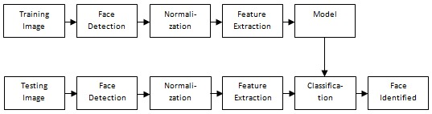**

**Fig. 1. Stages of the process of facial recognition**

This figure is a sample that shows the Stages of the process of facial recognition as mentioned as we see it goes through multiple stages as we clarified it step by step in the previous lines at the end of it we can see that the image got identified.

**Face Detection Techniques**

Face detection algorithms have been classified in a number of ways, which have been given. Face recognition algorithms can be classified into one of four categories, with some algorithms belonging to more than one category.

**1. Knowledge-Based:**

The knowledge-based technique relies on human understanding to follow a set of rules in order to recognize faces. For instance, the nose, eyes, and mouth of a face must all be at specific angles and distances from one another. The biggest disadvantage of these tactics is how difficult it is to create an appropriate set of criteria. There may have been a significant number of false positives if the criteria were either very general or overly specific. This approach by itself falls short and is unable to recognize several faces in a huge collection of images.

**2. Feature-Based:**

By removing structural traits from the faces being searched for, the feature-based method finds faces. Prior to being utilized to differentiate between face and non-facial body components, it is trained as a classifier. The ultimate objective is to move beyond the boundaries of our innate perception of faces. The authors claim that this method, which is divided into various portions and contains images with multiple faces, has a success rate of up to 95%.

**3. Matching of Templates:**

The Template Matching technique, which employs pre-defined or parameterized face templates to identify or detect faces by comparing them to the input photographs, can be used to locate or detect faces. As an illustration, the four components of the human face are the eyes, the facial features, the nose, and the lips. Additionally, a face model could be built purely from edges by employing the edge detection method. Despite being simple to create, this approach falls short when it comes to face detection. On the other hand, deformable templates have been proposed as a remedy for these problems. A method for locating matches between two templates is template matching.

**4. Appearance-Based:**

A collection of delegate training face photos is required by the appearance-based technique to find face models. All other performance evaluation techniques fall short compared to the appearance-based approach. Appearance-based methods rely on statistical analysis and machine learning methods to find relevant traits in face photographs. These methods are used to find relevant traits in face photos. The extraction of facial features for the purpose of face recognition also use this method. The appearance-based model is then further separated into sub-methods for face detection, including the following:

* **Eigenface-Based:** The Eigenface technique, a method of effectively modelling faces using Principal Component Analysis, is used to perform face recognition.
* **Distribution-Based:** Techniques like PCA and Fisher's Discriminant, both of which are based on probability distributions, can be used to characterize facial patterns. In the input image, there is a trained classifier that correctly separates instances of the target pattern class from instances of the background image pattern class.
* **Neural-Networks:** Numerous detection problems, including those involving object, face, emotion, and face identity, have been successfully resolved using neural networks.
* **Support Vector Machine (SVM):** Support Vector Machines (SVMs) maximize the difference in likelihood between the decision hyperplane and each of the instances in the training set.
* **Sparse Network of Winnows**: A sparse network with two goal nodes—one representing face patterns and the other representing non-facial patterns—was chosen as the design approach. Compared to the alternative, it is quicker and more effective.
* **Hidden Markov Model:** The states of the model, which are frequently shown as strips of pixels, would indicate the model's facial traits. HMMs are frequently combined with other techniques to build detection systems.
* **Inductive Learning :** Face detection has been accomplished via the use of this method. This is accomplished via the use of algorithms such as Quinlan's C4.5 or Mitchell's FIND-S.

**Life Applications of Face Recognition System**

The ability to apply face recognition technology in a variety of applications has made it more and more important in recent years. It has become an indispensable tool in many facets of life due to its capacity to precisely identify a person from a digital image or video stream. We will look at some of the practical uses of facial recognition systems in this literature review.

**1: Security**

One of the fields in which facial recognition technology is most frequently used is security. Face recognition technology is utilized in government buildings, banks, and airports to detect and identify potential threats. The device can also be used to monitor public spaces for criminal behavior and restrict access to restricted regions. For instance, the London Metropolitan Police employed live facial recognition technology in 2019 to scan crowds for wanted individuals by looking at people's faces. The police were able to identify and apprehend numerous people thanks to technology.

**2: Healthcare**

The use of face recognition technology in this industry is significant. The technology can be used to monitor patients' vital signs and identify them. Additionally, it can be used to monitor a patient's medication and spot any health issues. For example, the Niramai business has created a system to identify breast cancer using thermal imaging and AI. The technology examines breast thermal images to find anomalous patterns that could be signs of malignancy.

**3: Retail**

To enhance the consumer experience and deter theft, face recognition technology is widely used in the retail sector. Retailers are utilizing the technology to personalize marketing campaigns, analyze consumer behavior, and discover devoted clients. Like, Alibaba, a Chinese retailer, has created a system dubbed "Smile to Pay" that enables users to pay for goods using face recognition technology. Customers can complete transactions quickly using the system, which combines facial recognition with mobile payments.

**4: Education**

Face recognition technology is employed in this industry as well. Utilizing technology allows for the personalization of learning processes as well as the tracking of attendance and student behavior. For instance, a school in Hangzhou, China, is tracking student attendance using facial recognition technology. As students enter the room, the system employs cameras placed in the classrooms to scan their faces. If a student is missing or not paying attention, the system can notify the teacher.

**Successful Use Cases of Face Recognition System**

**5: Law enforcement**

It is one of the most successful uses of face recognition technology. This technology has been utilized to aid in the investigation of crimes and the identification of suspects. In 2018, for example, the New Delhi Police employed facial recognition technology to locate 3,000 missing children in just four days.

**6: Banking**

Face recognition technology has been used successfully in the banking business as well. The technology can be used to verify consumer identities and prevent fraud. In China, for example, the Agricultural Bank of China use face recognition technology to authenticate the identities of consumers seeking to create new accounts.

**7: Airports**

Airports are another successful application of face recognition technology. The technology has the potential to boost security while also speeding up the check-in process. For example, Changi Airport in Singapore implemented a facial recognition system in 2018 that allows visitors to check in, drop off their bags and pass through immigration without having to produce their passports.

Face recognition technology has become an essential tool in many areas of life. Its ability to accurately identify individuals has made it a valuable tool in security, healthcare, retail, and education. As this technology continues to improve, we can expect to see even more life applications in the future. However, it is also important to consider the ethical implications of this technology, including privacy concerns and potential biases.

**What is the relation about linear algebra and face Recognition?**

Linear algebra plays a significant role in face recognition technology. Face recognition systems typically use mathematical representations of faces known as face embeddings. These embeddings are typically generated using deep learning algorithms, which are based on convolutions and matrix multiplications, both of which rely heavily on linear algebra concepts. For instance, principal component analysis (PCA) Is a linear algebra technique used to reduce the dimensionality of facial images, making It easier and faster to compare and match them. The same applies to techniques such as singular value decomposition (SVD), which helps In the identification of the key features of the face that are unique to an Individual. These features are essential In developing a face recognition system that can accurately match individuals based on their facial features. Eigenfaces is another popular technique used in face recognition systems, which Is based on matrix algebra. This technique involves representing faces as a linear combination of eigenfaces, which are obtained as the eigenvectors of the covariance matrix of the facial Images. This way, the system can detect the unique features of each face and match them with the corresponding person.

The use of linear algebra in face recognition systems is crucial, facilitating the identification and matching of facial features across different images and allowing for accurate and reliable face recognition.

**The development stage of face recognition and related technologies**

Face recognition technology has undergone significant development in recent years, with advances in machine learning, computer vision, and artificial intelligence (AI) contributing to its Increased accuracy and efficiency. The history of face recognition technology can be traced back to the 1960s when early researchers began to create systems that could Identify faces from photographs. These early systems relied on simple algorithms that compared basic facial features like the distance between the eyes, eyebrows, nose, and mouth.

The use of eigenfaces in face recognition relies heavily on linear algebra. This method uses linear algebra to compute the principal components (eigenfaces) and transform the face Images into this new space. The face images are represented as points in a high-dimensional space (the number of dimensions is equal to the number of eigenfaces employed). Using principle component analysis (PCA), a linear algebra approach, the eigenfaces are first calculated. The dataset's covariance matrix is produced after the face photos have been mean-subtracted. The primary components, or eigenfaces, of this covariance matrix are the eigenvectors that encapsulate the most important fluctuations in the dataset. The next step Is to project each face picture onto each eigenface in order to change It into the eigenface space. The facial picture is multiplied by the eigenvector matrix In order to do this via matrix multiplication. The facial image is represented by the weight vector that results In the eigenface space.

Last but not least, the k-Nearest Neighbor (kNN) approach is used to classify new face photos. This algorithm needs determining the Euclidean distance In eigenface space between the test image and the training images. Since the distance can be calculated using matrix multiplication and vector operations, linear algebra Is once more involved In this process.The computation of eigenfaces, the transfer of face Images into the eigenface space, and the classification of fresh face images using kNN all heavily rely on linear algebra.

However, it wasn't until the 1990s that significant progress was made in face recognition technology. This was due to the development of more advanced machine learning algorithms like neural networks, which allowed researchers to create more sophisticated and accurate facial recognition systems. One of the most Important breakthroughs at this time was the development of the eigenface algorithm, which used a mathematical method to analyze the statistical properties of faces and match them to stored Images. In recent years, the development of deep learning algorithms has had a major impact on the field of face recognition. These algorithms enable models to learn more *complex* features of faces, allowing for even greater accuracy and efficiency. One of the most Important applications of face recognition technology has been in the security Industry. Face recognition systems are now used to Identify individuals at airports, In public spaces, and In other security contexts.

Concerns have been raised about the limitations and potential misuse of face recognition technology. There are concerns about bias and discrimination, as well as potential privacy violations. As such, there is ongoing research and development aimed at addressing these issues and increasing the reliability and ethical use of face recognition technology.

* **Methodology**

The methodology of this research is focused on the use of Eigenfaces, a method for face recognition that uses linear algebra to represent and analyze the features of a human face. Face re cognition technology is based on the idea that every person has a unique facial shape that can be analyzed and recognized by a computer system. The first step of this methodology is to collect a dataset of face images that will be used for training and testing the algorithm. The collected images are then preprocessed to remove any noise or inconsistencies that may hinder the accuracy of the recognition system.

Next, the Eigenfaces method is applied, which involves creating a set of eigenvectors from the dataset of face images. These eigenvectors represent the most significant features of the faces in the dataset, and they can be used to represent any face image as a linear combination of these eigenvectors. The algorithm then uses these eigenvectors to represent and compare the input face image with the dataset of known faces.

To implement the Eigenfaces method for face recognition, Suppose we have a dataset of face images represented as a matrix X, where each row of X represents an individual face image and each column represents a pixel in the image. We can preprocess the images, compute the mean face, and difference vectors as described in the methodology.

Next, we compute the covariance matrix of the difference vectors as follows:

1. C = 1/N \* (X - M)' \* (X - M)

where N is the number of face images in the dataset, X is the matrix of preprocessed face images, and M is the mean face.

We can then compute the eigenvectors and eigenvalues of C using eigendecomposition:

1. [V, D] = eig(C)

where V is a matrix of eigenvectors and D is a diagonal matrix of eigenvalues.

The eigenvectors in V represent the directions in which the faces in the dataset vary the most, while the corresponding eigenvalues in D represent the amount of variation along each eigenvector.

To select a subset of the eigenvectors that contain most of the significant facial features, we can sort the eigenvalues in descending order and select the first k eigenvectors with the highest eigenvalues.

Finally, to project a new face image onto the selected eigenvectors, we can compute the dot product of the difference vector of the new face image with each of the selected eigenvectors:

1. W = (X\_new - M) \* V(:, 1:k)

where X\_new is the preprocessed new face image and W is a vector of weights that represent the new face image in the low-dimensional space defined by the selected eigenvectors.

To classify the new face image, we can compare its weight vector with the weight vectors of the known faces in the dataset using a distance metric such as Euclidean distance.

The Eigenfaces method is important in face recognition because it is a computationally efficient way of representing facial features in a low-dimensional space. This allows for fast and accurate matching of new faces against a database of known faces. The method is associated with linear algebra because it relies on techniques such as eigendecomposition and dot product, which are fundamental concepts in linear algebra. Other methods that can be used for face recognition include Local Binary Patterns, Principal Component Analysis, and Deep Learning-based methods. However, Eigenfaces remains a popular and effective method due to its simplicity and efficiency.

the eigenvectors are typically called eigenfaces due to their resemblance to real faces, as shown in this .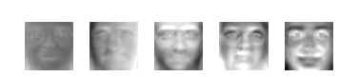

(Top 5 eigenfaces computed using the ORL database of faces sorted from most variance (left) to least variance (right))

New faces can be projected onto the subspace spanned by the eigenfaces to obtain the weights of the linear combination of eigenfaces needed to reconstruct them. This idea was used a lot to identify faces by comparing the weights of new faces to the weights of faces in a gallery set. A probabilistic version of this approach based on a Bayesian analysis of image differences we model two mutually exclusive classes of variation between two facial images: intra-personal (variations in appearance of the same individual, due to different expressions or lighting) and extra-personal (variations in appearance due to a difference in identity). In this method, two sets of eigenfaces were used to model intra-personal and interpersonal variations separately. Many other variations of the original eigenfaces method have been proposed. For example, a nonlinear extension of PCA based on kernel methods, namely kernel PCA , independent component analysis (ICA), a generalization of PCA that can capture high-order dependencies between pixels, and a two-dimensional PCA based on 2D image matrices instead of 1D vectors.

The Eigenfaces method has proven to be a successful approach for face recognition, with applications in various fields such as security systems, law enforcement, and access control. It is particularly beneficial because it can recognize faces regardless of the lighting, pose, and facial expression. The method's success is closely related to linear algebra, which provides the mathematical foundation for representing and manipulating the facial features of the input images.

The Eigenfaces approach for facial recognition can be summarized as follows:

1-Gather a set of distinct facial images for the individuals whose identity needs to be recognized. It is recommended to have multiple images for each person, showing variations in expression and lighting. For example, a set of four images for ten individuals would result in 40 images, represented by M.

2-Calculate the (40 x 40) matrix L, obtain its eigenvectors and eigenvalues, and select the top M' eigenvectors corresponding to the highest eigenvalue (M=10 in this case).

3-Combine the training set of normalized images using equation (1) and generate M' eigensurfaces.

4-For each known individual, compute the eigensurface pattern vector IR (using formula (S)) from their original (four) images individually. Set a threshold of 8, which determines the maximum allowed distance from each face class (according to equation (9)).

5-For each new face image, calculate its pattern vector 0 and its distance to all known classes, Distance E into face space. If the shortest distance (Ek) is less than 8, then the image is classified as a known individual. If the distance E is less than 8, the image is classified as "unknown" and can be used to start a new face class.

6-If the new image is recognized as a known person, it can be added to the original set of known facial images and eigenfaces can be recalculated (Steps 1-4). This allows for the expansion of the face space and the detection of more known individuals.

In addition to the Eigenfaces method, other approaches to face recognition include Local Binary Patterns (LBP), Principal Component Analysis (PCA), and Convolutional Neural Networks (CNNs). These methods use different techniques to represent and compare facial features, and they have their strengths and weaknesses.

In conclusion, the Eigenfaces method is a powerful tool for face recognition that uses linear algebra to represent and analyze the features of human faces. This methodology involves collecting a dataset of face images, preprocessing them, computing the eigenvectors and eigenvalues, selecting the most significant eigenvectors, projecting new faces onto these eigenvectors, and classifying them using the weights. The method has broad applications and can be used in combination with other approaches to achieve better results.

# Results and Discussion

We used Python Code, in addition to its libraries, to test our algorithm. In our test data, we used black and white images, with the same dimension, showing subjects' faces. Different dimension images, when used, caused errors in the code, if not properly handled.

Figure

The training set is used to determine the ten eigenfaces with the highest eigenvalues. They're referred to as the ghost faces.

**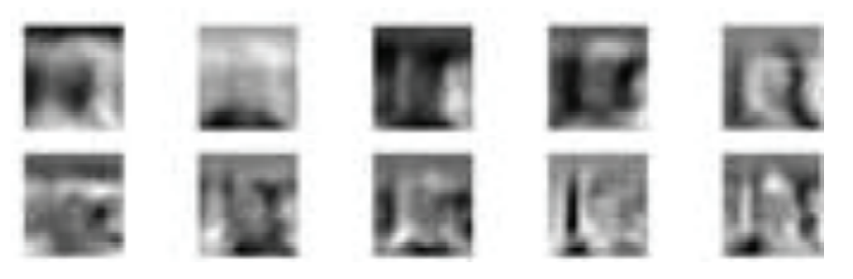**

Figure

The ghost faces appear to be sharper for some databases. For some others, they are blurry, as in this case. The backgrounds and other features of the photographs affect how sharp the images are.The database utilized for this project has 5 pictures of 1 person in it. 4 photos in all are used. The training set is used to compute the average face. Fig. (number of fig) displays a few photos from the training set.

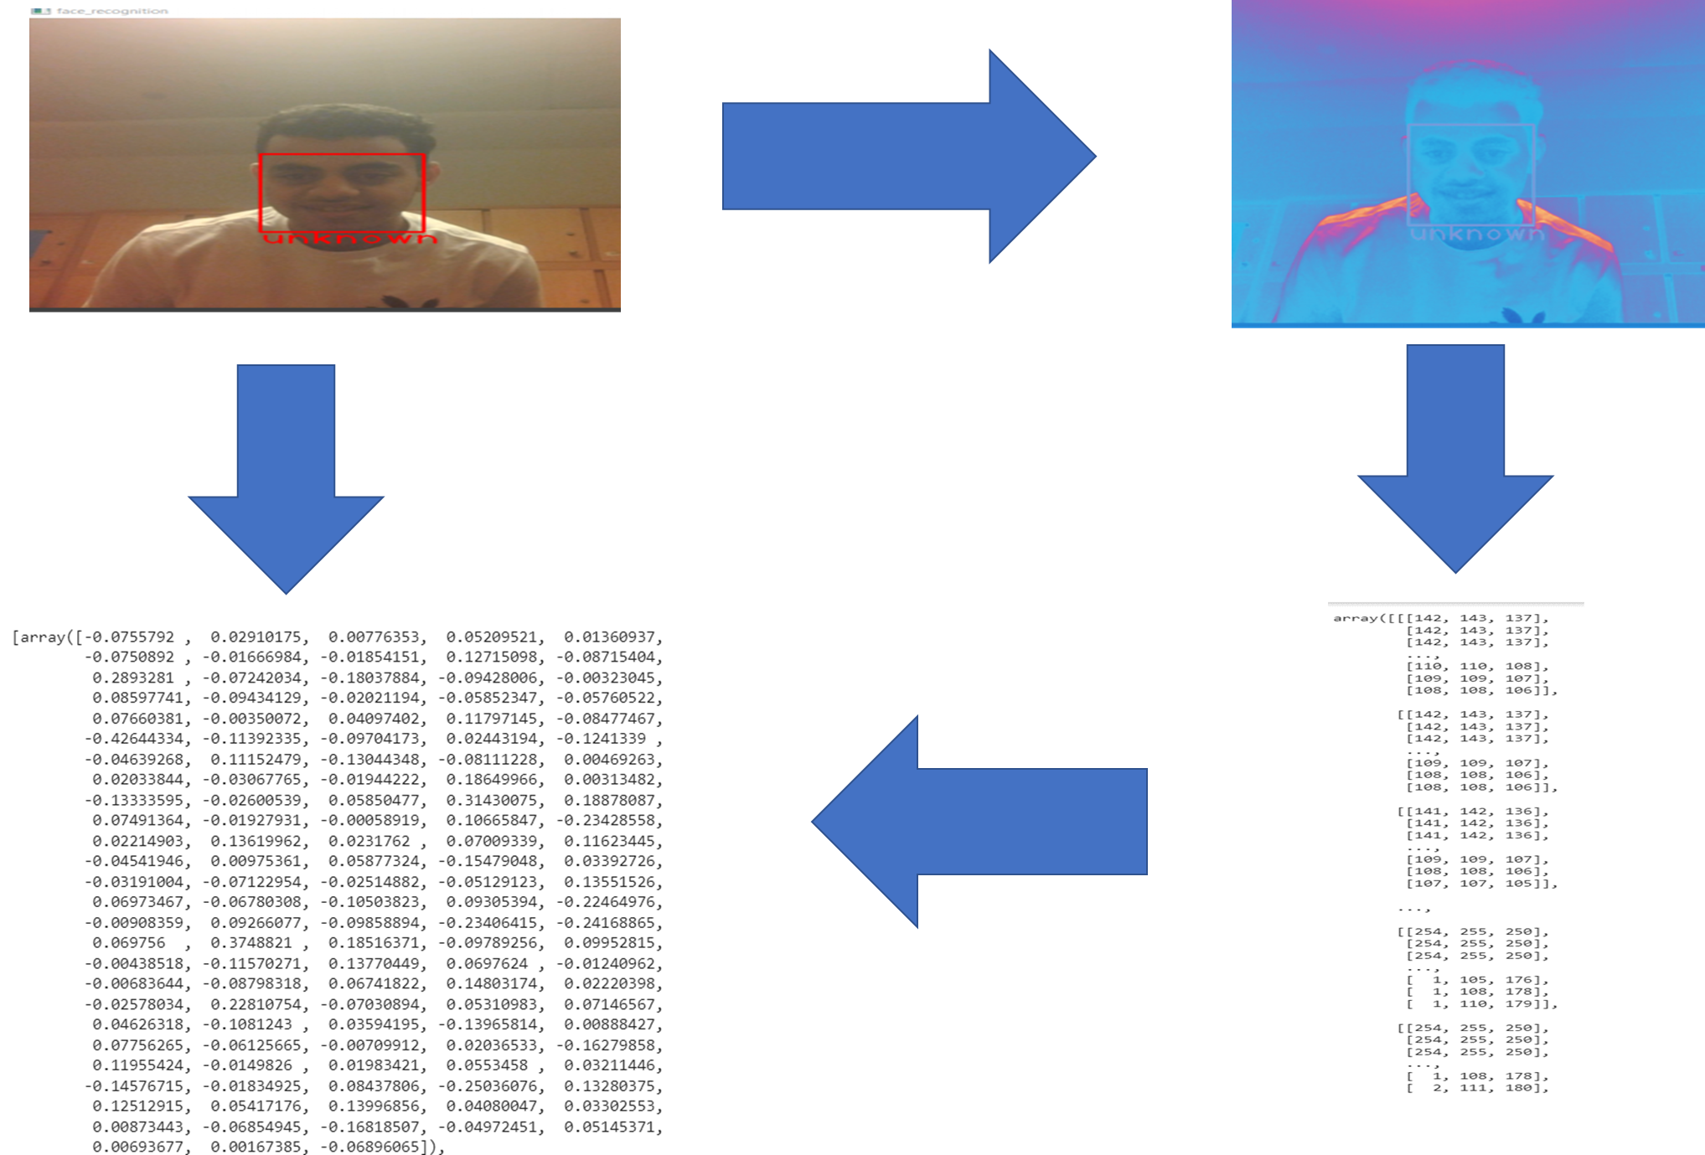

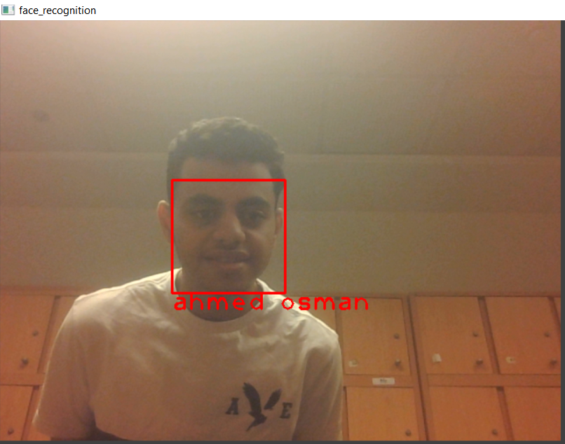

Despite its simplicity and practicality, our model correctly predicted subjects’ identities with an accuracy of around me 70%, even when the subjects were showing various facial expressions.

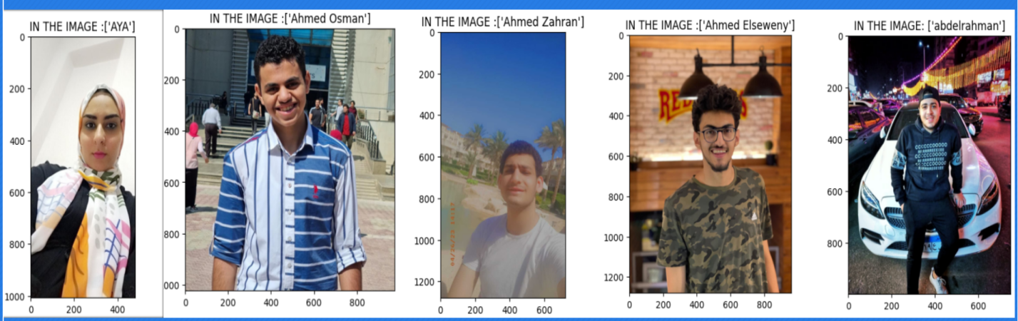

Figure

In addition, part of 30% is in error because color images are not determined by the algorithm. Moreover, they were stationed in the middle of the light at the face.

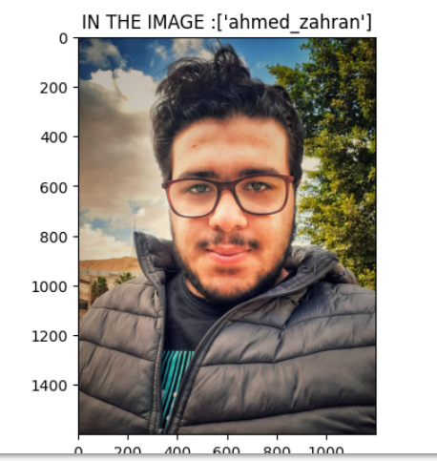

Figure

The second part of the error The model sees two people with the same name, although they are different .

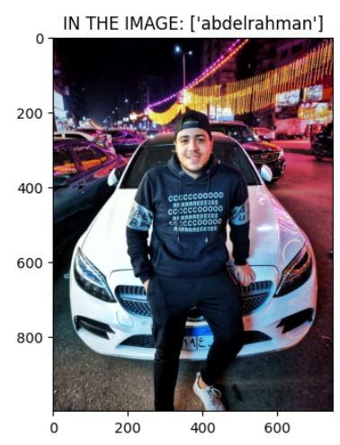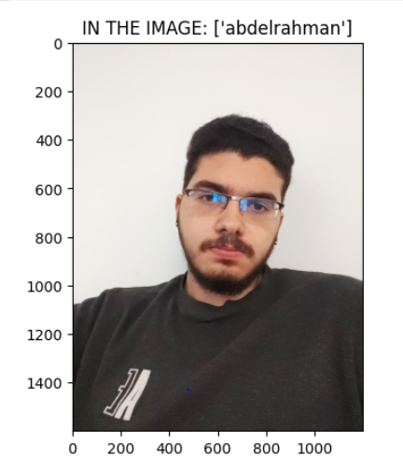

Figure Figure

Compare between two images

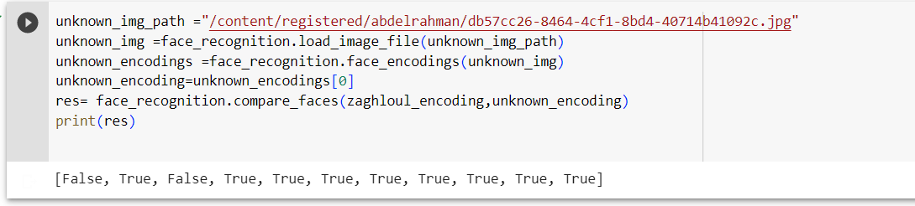

Figure

Face recognition is a computer vision task that involves identifying and verifying the identity of a person based on their facial features. It is a common application of machine learning and computer vision algorithms. Linear algebra plays a crucial role in many aspects of face recognition. One important application of linear algebra in face recognition is in the computation of face embeddings. A face embedding is a high-dimensional vector that represents the features of a person's face. These embeddings are computed using deep neural networks, which involve many matrix computations, such as matrix multiplication, matrix inversion, and matrix factorization.

Once the embeddings are computed, linear algebra is also used to compare them and determine if two face images are of the same person or not. This is done using various distance metrics, such as Euclidean distance, cosine similarity, or Mahalanobis distance, which are all based on linear algebra concepts. Overall, linear algebra provides a mathematical foundation for many of the algorithms used in face recognition and is essential for understanding how these algorithms work and how to optimize their performance.

Link\_code : [https://colab.research.google.com/drive/1O3KG66ifGhQdyf6UKDqJB2tyCuS49JX1?usp=sharing#scrollTo=jKclFdn5DBgk](https://colab.research.google.com/drive/1O3KG66ifGhQdyf6UKDqJB2tyCuS49JX1?usp=sharing" \l "scrollTo=jKclFdn5DBgk)

# conclusion

In conclusion, Face recognition technology is a field of computer vision that involves identifying and verifying the identity of an individual from a digital image or video frame of their face. It utilizes artificial intelligence to compare and identify individuals by analyzing and contrasting photos of human faces with a database of recognized faces. The three main components of this research project will be studied, with a focus on the eigenvector method for feature extraction. The report will also analyze the limitations of the face databases commonly used to evaluate these algorithms, which may impact the accuracy and reliability of the technology. Facial recognition technology uses eigenvectors and eigenvalues to represent images.

FaceID, the system used by iPhones to unlock them, identifies and recognizes one person as the single owner of the device, limiting access to others. Facial recognition technology matches faces of persons passing by special cameras to pictures of people on a watch list, going beyond simply unlocking phones. Step 1: Face detectionFinding faces within a group of things is the initial step in correctly recognizing faces. Step 2: Face alignmentFace recognition technology matches faces of persons passing by special cameras to pictures of people Face recognition and matching is used to compare the face's measurements to those of other faces recorded in the database. Face verification is the final stage of the machine learning process for face recognition.

Face detection algorithms can be classified into four categories: Knowledge-Based, Feature-Based, Matching of Templates, and Edge Detection. Face recognition technology has become increasingly important in recent years due to its capacity to accurately identify a person from a digital image or video stream. Techniques such as template matching, appearance-based, Eigenface-based, Distribution-based, Neural-Networks, Sparse Network of Winnows, Hidden Markov Model, and Inductive Learning have been used to find relevant traits in face photos and extract facial features for the purpose of face recognition. Life Applications of Face Recognition System The ability to apply face recognition technology in a variety of applications has made it more and more important in recent years. In 2018, the New Delhi Police employed facial recognition technology to locate 3,000 missing children in just four days.

Face recognition technology has become an essential tool in many areas of life, such as banking, airports, security, healthcare, retail, and education. Linear algebra plays a significant role in face recognition technology, with techniques such as PCA and SVD used to reduce the dimensionality of facial images. Eigenfaces is another popular technique used in face recognition systems, which involves representing faces as a linear combination of eigenfaces. Face recognition technology has undergone significant development in recent years, with advances in machine learning, computer vision, and artificial intelligence (AI) contributing to its increased accuracy and efficiency. This research focuses on the use of Eigenfaces, a method for face recognition that uses linear algebra to represent and analyze the features of a human face.

The Eigenfaces method is a powerful tool for face recognition that uses linear algebra to represent and analyze facial features. It uses two sets of eigenfaces to model intra-personal and extra-personal variations and is based on techniques such as eigendecomposition and dot product. Face recognition is a computer vision task that involves identifying and verifying the identity of a person based on their facial features. Linear algebra is essential for face recognition, as it is used to compute face embeddings and compare them to determine if two face images are of the same person.

**References**

Adjabi, I., Ouahabi, A., Benzaoui, A., & Taleb-Ahmed, A. (2020b). Past, Present, and Future of Face Recognition: A Review. *Electronics*, *9*(8), 1188. <https://doi.org/10.3390/electronics9081188>.

Mu, Xiaohui ., Li, Siying ., Haipeng., Peng. (2020). A Review of Face Recognition Technology. IEEE Access. PP. 1-1. 10.1109/ACCESS.2020.3011028. <https://www.researchgate.net/publication/343118558_A_Review_of_Face_Recognition_Technology>

Çarıkçı, M., & Özen, F. (2012). A Face Recognition System Based on Eigenfaces Method.*ProcediaTechnology*,*1*, 118–123. <https://doi.org/10.1016/j.protcy.2012.02.023>

A. Kapoor and J. H. Lee, "Compositional Imitation Learning: Explaining and executing one task at a time," arXiv preprint arXiv:1811.00116, Nov. 2018. Available: [https://arxiv.org/pdf/1811.00116.pdf](https://arxiv.org/pdf/1811.00116.pdf" \t "_new).

W. Zhao, R. Gummadi, and K. Papagiannaki, "Theoretical Analysis of Delay Bounds in Spatial TDMA-based Ad Hoc Networks," in Proc. of the 22nd Annual Joint Conference of the IEEE Computer and Communications Societies (INFOCOM), San Francisco, CA, USA, Mar. 2003, pp. 711-721. doi: 10.1109/INFCOM.2003.1209312. Available: [https://inc.ucsd.edu/mplab/users/marni/Igert/Zhao\_2003.pdf](https://inc.ucsd.edu/mplab/users/marni/Igert/Zhao_2003.pdf" \t "_new)

J. A. Findlater, "Facial recognition technology: Its merits and demerits," Proc. Power and Energy Conf., May 2019. [Online]. Available: [https://pceinc.org/wp-content/uploads/2019/11/20190528-Facial-Recognition-Article-3.pdf](https://pceinc.org/wp-content/uploads/2019/11/20190528-Facial-Recognition-Article-3.pdf" \t "_new)

P. N. Belhumeur, J. P. Hespanha, and D. J. Kriegman, "Eigenfaces vs. Fisherfaces: recognition using class specific linear projection," IEEE Trans. Pattern Anal. Mach. Intell., vol. 19, no. 7, pp. 711-720, Jul. 1997. [Online]. Available: [https://cseweb.ucsd.edu/classes/wi14/cse152-a/fisherface-pami97.pdf](https://cseweb.ucsd.edu/classes/wi14/cse152-a/fisherface-pami97.pdf" \t "_new)

UpGrad. "Facial Recognition with Machine Learning." UpGrad Blog, 24 Jan. 2019, [https://www.upgrad.com/blog/facial-recognition-with-machine-learning/](https://www.upgrad.com/blog/facial-recognition-with-machine-learning/" \t "_new).

Kaspersky. "What is Facial Recognition?" Kaspersky Resource Center, [https://www.kaspersky.com/resource-center/definitions/what-is-facial-recognition](https://www.kaspersky.com/resource-center/definitions/what-is-facial-recognition" \t "_new).

CameraLyze. "4 Popular Face Detection Methods." CameraLyze Blog, 14 Nov. 2018, [https://www.cameralyze.co/blog/4-popular-face-detection-methods](https://www.cameralyze.co/blog/4-popular-face-detection-methods" \t "_new).